BO arcade onderzoek

**Lijst van spellen:**

* 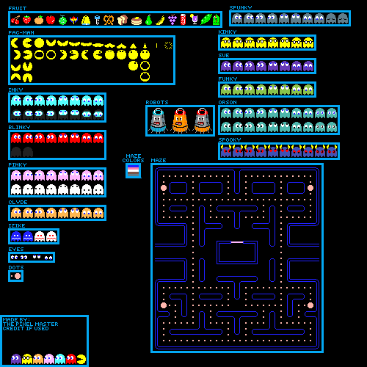Pac-man

Art sheet pac-man

* Flappy bird
* Donkey kong jr.
* Digdug
* Space invaders
* Donkey kong
* Thetherus
* Pong
* Q-bert
* Frogger
* Asteroids
* Super pac man
* Ms. Pac man
* Bubble bobble

**Lijst van mechanics:**

* Move right (d)
* Move left (a)
* Move up (w)
* Move down (s)
* Jump (space)
* Highscore
* Deaths
* Loops
* Shooting
* Score
* Higher level > higher difficulty

**Lijst gekozen mechanics:**

* Move right (d/arrow right)
* Move left (a/arrow left)
* Move up (w/arrow up)
* Move down (s/arrow down)
* Highscore
* Score
* Higher level > higher difficulty
* Deaths